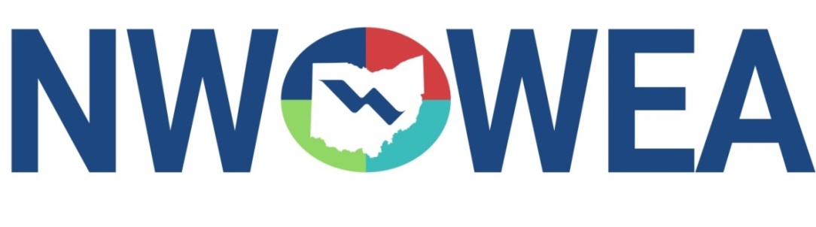

OWEA NW SECTION MEETING
May 15, 2019
City of Findlay, Ohio
Meeting at Boy Scout Camp Berry
11716 Co Rd 40, Findlay, OH 45840

8:00-8:30 am Registration and Networking Opportunities – Boy Scout Camp Berry;
Donuts, Coffee and Juice provided

8:30-8:45 am Welcome and NWOWEA Section Business Meeting

8:45-9:30 am Blanchard River Demonstration Farms Conservation Practices – 0.75 hour
Aaron Heilers

9:30-10:15 am I Need To Leave Early Today – 0.75 hour
Stephen Haughey – Frost Brown Todd

10:15-10:30 am Break

10:30-11:15 am A Design Build Procurement in Ohio – 0.75 hour
Todd – Kokosing Construction

11:15-11:45 am Experience Speaks NoW – 0.50 hour
John Eckel – City of Perrysburg
Doug Borkosky – Baker & Associates

11:45-12:00 pm Raffle Prizes & Adjourn for Lunch

1:00 pm
Golf Outing at Sycamore Springs Golf Course
11492 Township Rd 25, Findlay, OH
$20 additional – includes Golf, Cart, and Prizes.

1:00 pm
Findlay Water Pollution Control Center Tours – 1.0 hour
1201 South River Rd, Findlay, OH

Northwest Section Would Like To Thank the Following Sustaining Sponsors:

Alloway Environmental Testing, Lima, OH
Baker and Associates, Carey, OH
BissNuss, Inc., Westlake, OH
CT Consultants, Mentor, OH
Dmytryka Jacobs Engineers, Inc., Toledo, OH
Jones and Henry Engineers, Ltd., Toledo, OH
Perrysburg Pipe and Supply Co., Perrysburg, OH
Peterson Construction Co., Wapakoneta, OH
Poggemeyer Design Group, Bowling Green, OH
Smith Environmental, Columbus, OH
The Bergren Associates, Sylvania, OH
Waterworks Systems and Equipment, Inc., Lakeland, MI

